**The specific task is to bring out some Data from the different directories**

**Students might know:** Spatial Analysis consists of some very important key stages: *Understanding and identifying the goal*, *preparing the data, choosing the appropriate methods and skills, conducting research and evaluating the results.*

**Learning objectives:** On this specific task student will work with CSV data, upload it into ArcGIS Online and represent the information on Web map.

**Required materials for the correct results and** [**earthquake prediction**](https://context.reverso.net/%D0%BF%D0%B5%D1%80%D0%B5%D0%B2%D0%BE%D0%B4/%D0%B0%D0%BD%D0%B3%D0%BB%D0%B8%D0%B9%D1%81%D0%BA%D0%B8%D0%B9-%D1%80%D1%83%D1%81%D1%81%D0%BA%D0%B8%D0%B9/earthquake+prediction)**:** CSV data (Earthquakes catalog, [https://earthquake.usgs.gov/earthquakes/search/),](https://earthquake.usgs.gov/earthquakes/search/),%20) software (ArcGIS online), hardware (PC).

**Completing tasks on this exercise:** The students will study and use the following skills- read and add required data to a map, to choose different basemap depends on specific task, create, change the style and symbology of data if necessary, customize pop-ups if necessary. The students will learn to use the Earthquake Catalog Data, distinguish the data of location with the help of filters and coordinates, distinguish the data of magnitude. Will be able to visualize and analyse time based earthquake data. To select earthquakes data from generated earthquake layer using sql queries by date, depth, longitude and etc. … Save and share the web map.

**PRACTICAL WORK**

**Exercise 1**. Find, select and download CSV data from earthquakes online catalog. The link is provided https://earthquake.usgs.gov/earthquakes/search/. Import data into ArcGIS online using Add data option and generate earthquakes location layer.

**Exercise 2**. Choose or change the basemap and layer style then configure symbology by using “select a drawing style” option to show areas with color ramp provided by ArcGis Online or create own style.

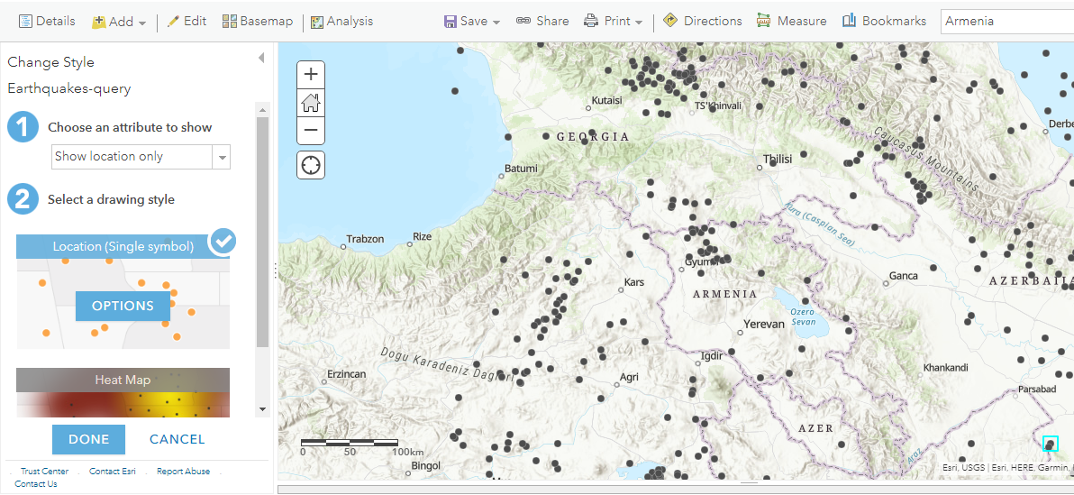

**Exercise 3**. Choose the map scale, which better describes the research area.

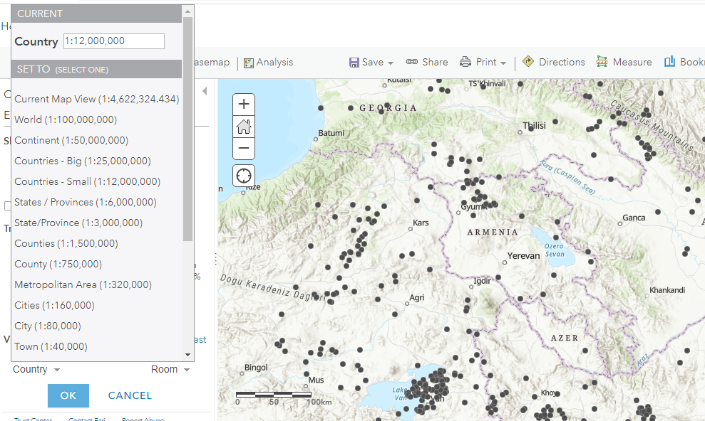

To search interested are type the name of location (Armenia) and press Enter.

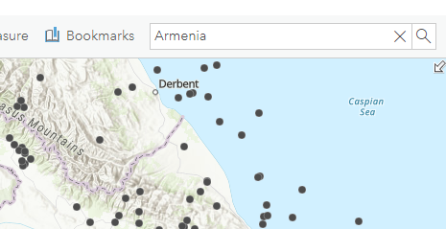

**Exercise 4**. Select earthquakes data which fits better to the task and choose them using filters (area, date, depth, longitude). 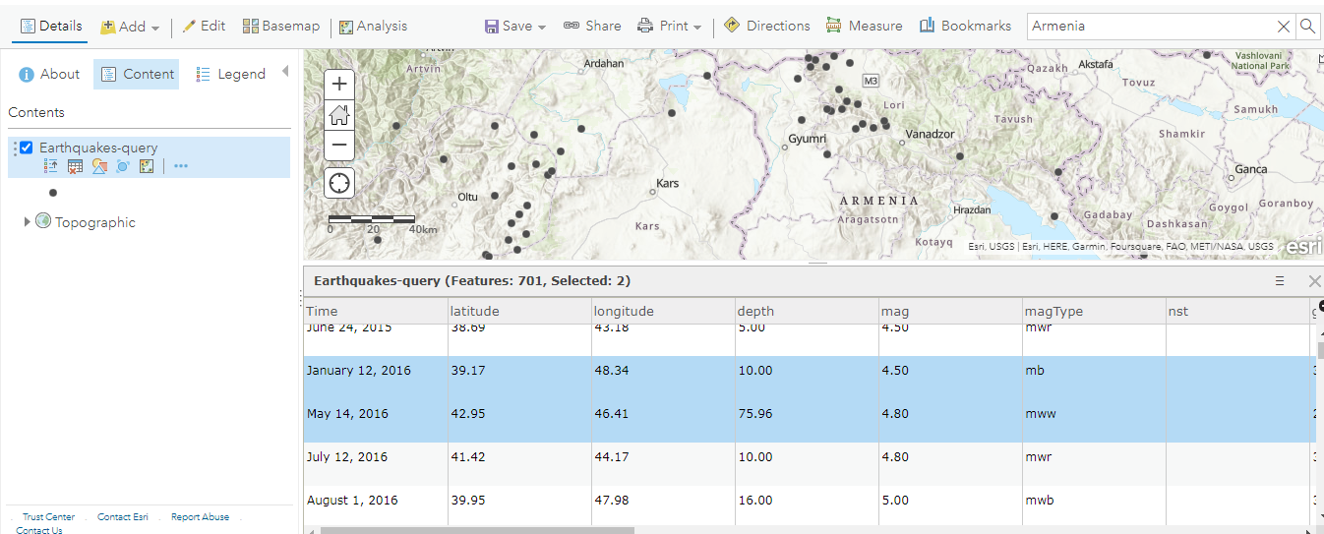

The finished map should be saved.

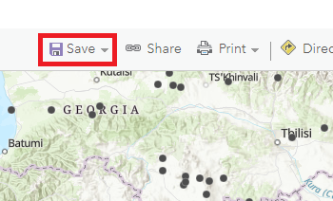

Chose Save option and fill all the fields (Title, Tags, Summary and Path to the folder)

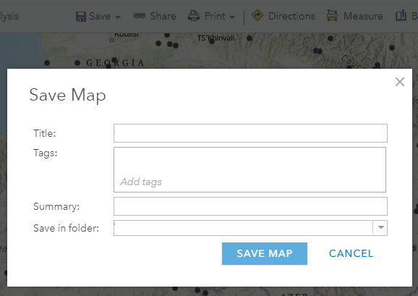

Using share option share the web map.

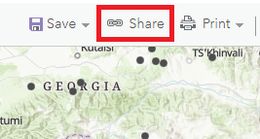

From dialog frame choose the sharing option which best fits. Link to this map field is showing the generated link. Also students can share the map by Facebook and Twitter.

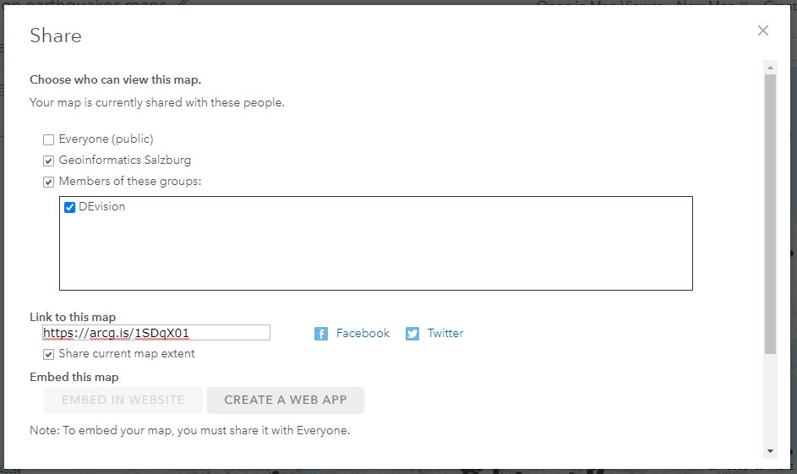

<https://zgis.maps.arcgis.com/apps/Viewer/index.html?appid=904cad5eab484d4091408f46d4003eae>