**PRACTICAL WORK #1**

**Sentinel-2 data on cyanobacteria bloom detection in Lake Sevan**

**Statement.**  This guide will show you how to acquire Copernicus satellite data using websites such as [www.sentinel-hub.com](http://www.sentinel-hub.com). Basic operations on images such as creating colour compositions and counting indicators, will be presented. The guide will focus on the use of optical satellite data from Sentinel-2.

**Objectives.** Get a basic introduction to the concepts of satellite revisit and coverage. Define suitable search criteria (time range, area, satellite, satellite product, visualization type) in EO. Understand the different levels of processing for Sentinel-2 products (L1C and L2A). Export images in EO Browser. Understand the concepts of RGB visualizations, and customize them in EO Browser. Compare images from different dates in EO Browser. Create a timelapse in EO Browser.

**Required materials.** Computer, Internet connection.

**Access to Eo browser**

1. Go to website [www.sentinel-hub.com](http://www.sentinel-hub.com/) and choose EXPLORE, then EO BROWSER.

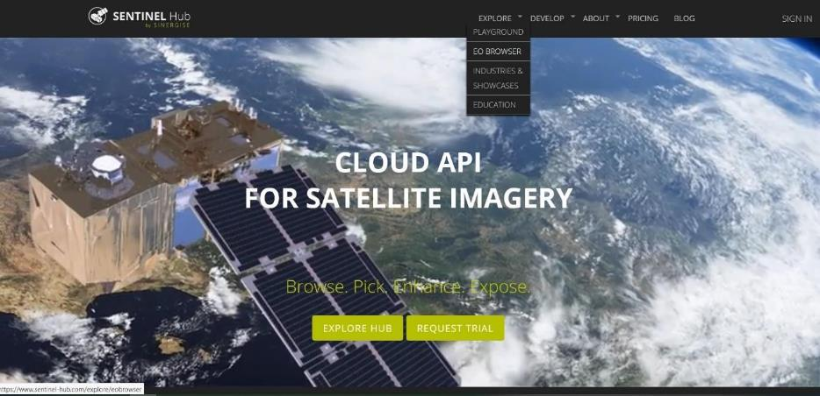

1. Then click START EXPLORING.

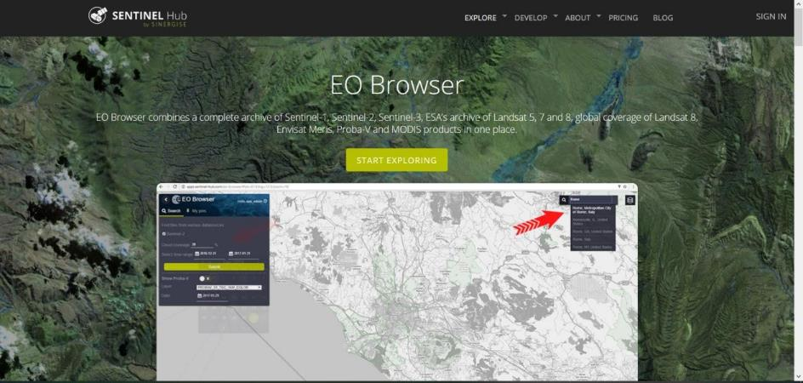

**Login**

A new screen will appear with the "Login" button on the left side of it.

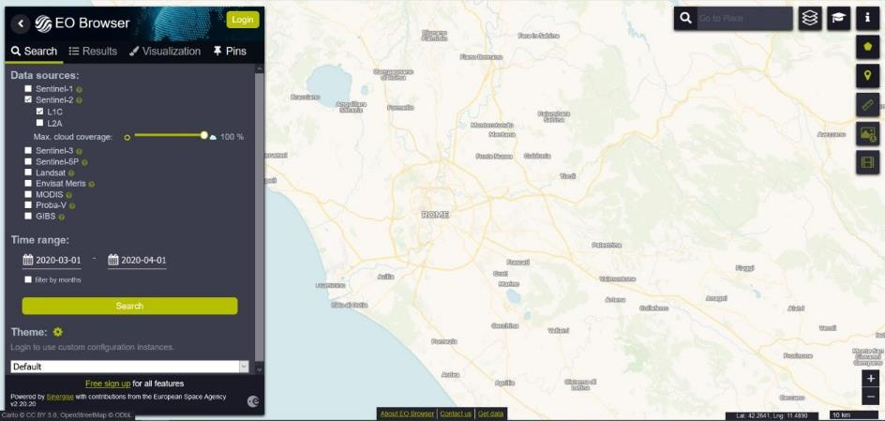

1. In the absence of an account, create one by clicking "Login" and then "Sign Up"

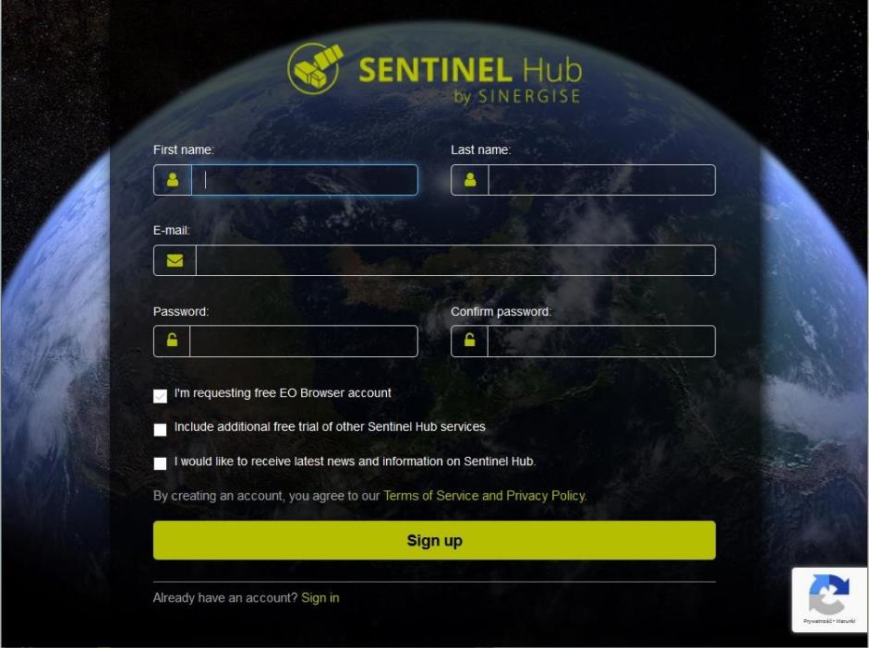

**Search**

1. Navigate to the area of Eastern Armenia (simply use your mouse to adjust the display as seen below. There is no need to upload polygons or enter coordinates). Or just type “Lake Sevan” in the search box (up right side of the screen).

On the left side, there is a menu where you can define your search. Additional search attributes will be displayed by checking the boxes next to the names of the satellites.

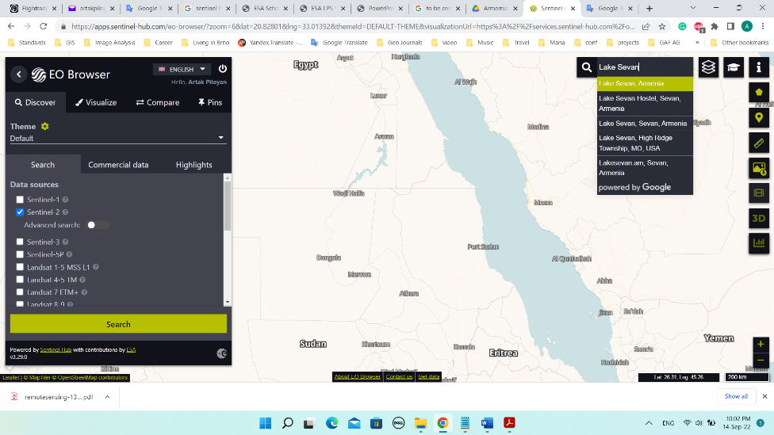

* L1C - not subjected to atmospheric correction;
* L2A – atmospheric corrected data;
* Max cloud coverage – maximum cloudiness of the image, defined by setting the appropriate value on the slider.

As the task is to concern optical data from Sentinel-2, select Sentinel-2, L2A, and set the cloud cover to 10%.

1. Time range – the period of time for which the data will be searched. Set from July 1, 2020 to July 31, 2020. Click "Search".

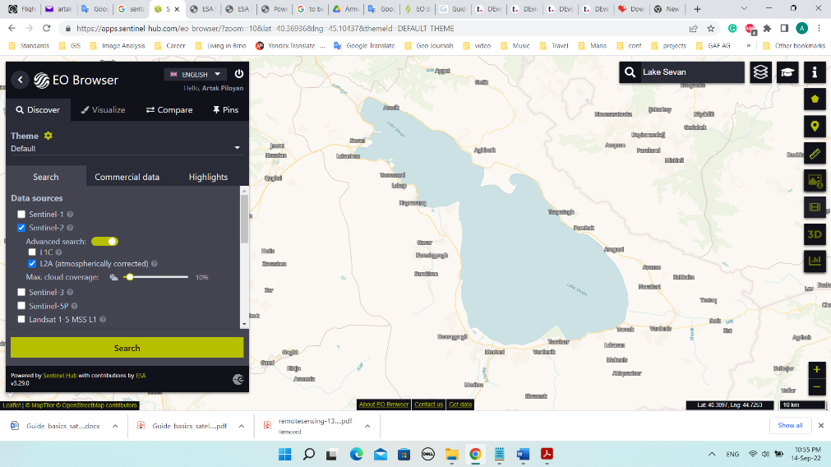

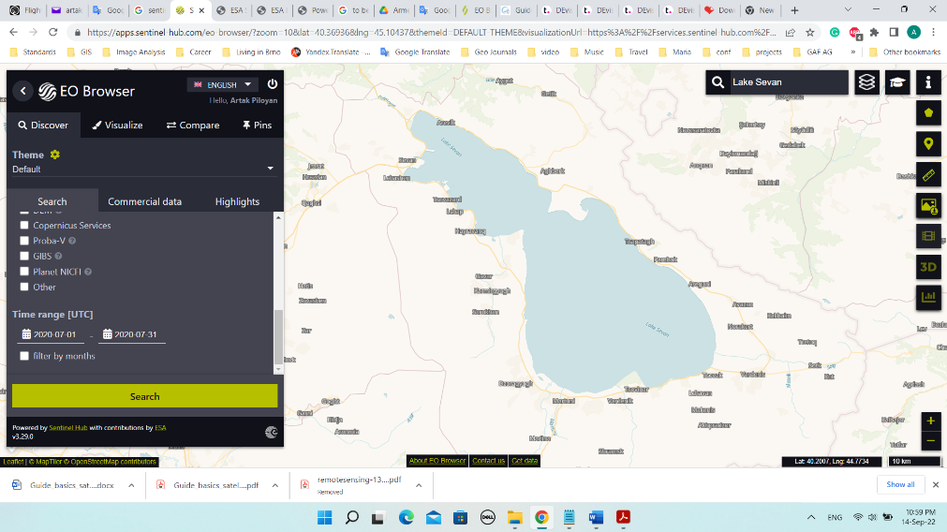

**Viewing of the results**

1. To see a list of found images, go to the "Results" tab. Select the image from 20.07.2020 and click "Visualize". You will automatically be moved to the "Visualization", where the selected image will be displayed in real colours (RGB).

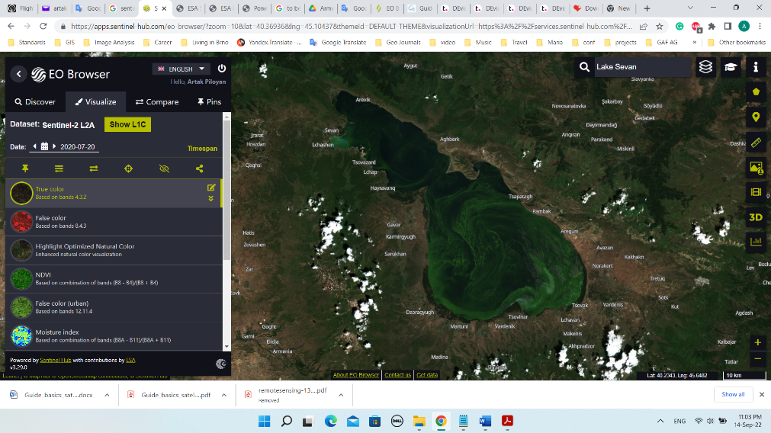

On the left side of the screen, a list will appear. You can how to display the image (colour composition or index). You can also choose the option of displaying classified image according to ESA algorithm.

* True color – true colours;
* False color – near infrared composition. Useful for analyzing vegetated areas;
* NDVI – a commonly used index of the condition of vegetation;
* False color (urban) – composition using two mid-infrared bands. Useful in classifying built-up areas;
* Moisture Index – an index providing information on moisture;
* SWIR – combination used for soil moisture monitoring, vegetation studies and various stages of crop growth;
* NDWI - an index that provides information on the water content of vegetation;
* NDSI – an index useful for classifying snow cover and water
* Scene classification map – image subjected to classification, due to the coverage of the area, according to ESA algorithm.

Below is an image displayed by the composition "NDWI".

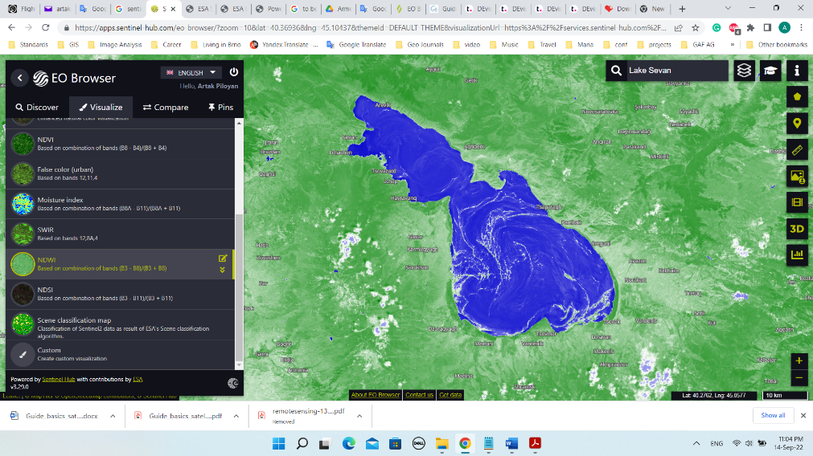

**Download**

1. To download an image, click the "Download image" icon on the right side of the screen.

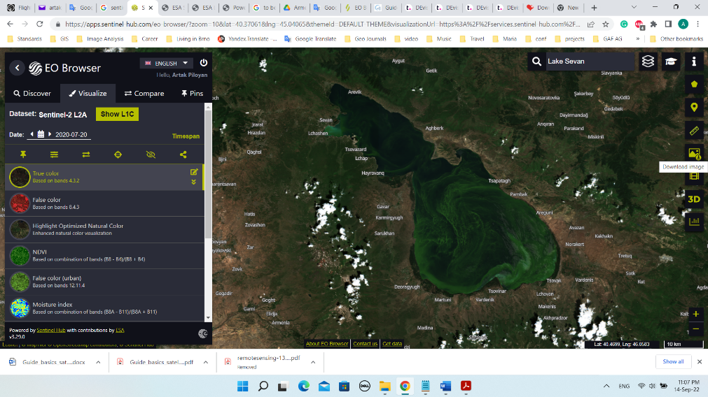

A new window will appear. The "Basic" section will be displayed. By selecting "Download" in this section, a .jpg image will be downloaded in real colors.

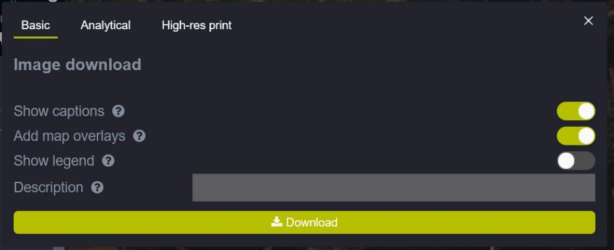

Going to the "Analytical" section, it is possible to select a georeferenced image - tiff. By clicking all the boxes in the "Raw" column, data from all bands will be retrieved.

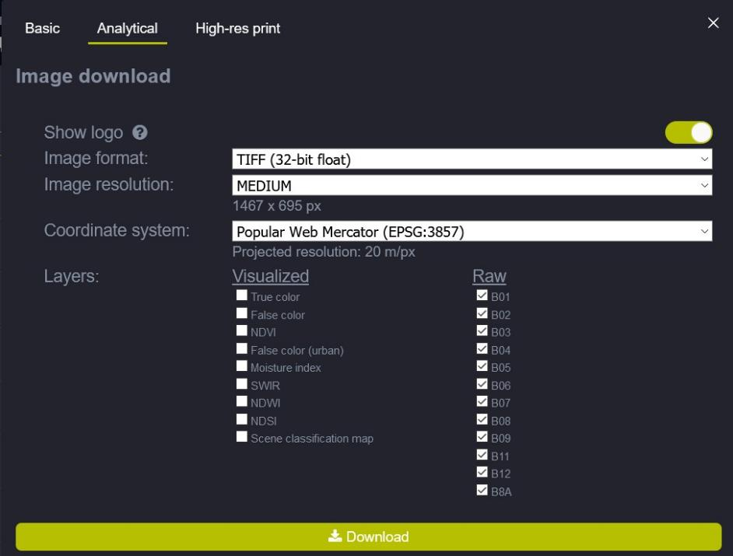

Click on "Download". Remember that only the data for the limited area (which is displayed in the window) will be downloaded, not the whole scene (it is a reason of the small file size).