Classification, symbolization and visual combination

**Conceptual exam questions**:

1. **What is the difference between Types of Grouping and Types of contrast?**

Please provide short answer in 2 sentences.

1. **Why do you need to take balance when creating a map?**

**Please provide short answer in a one paragraph.**

1. **Write a short essay on differences elements support the map on paper and on the web map. The essay should be no more than 500 words.**
2. **What kind of color scheme is used to display the map:**

- sequential;

- diverging;

- qualitative;

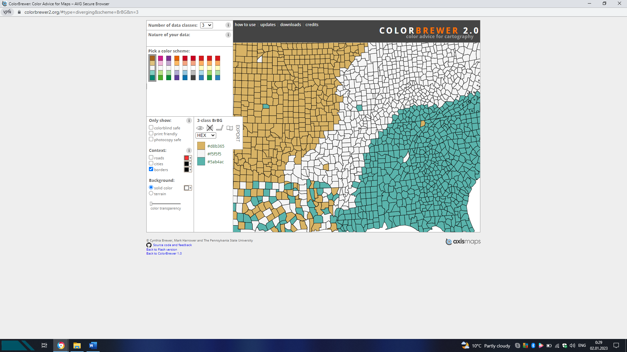

1. **What is the visual hierarchy? Please select the right answer.**

- graphical implementation of a ranked order of map elements such that the most important elements have the greatest visual prominence;

-  the ordering or ranking of all symbols and elements in the map according to their relative importance;

-both correct;

1. **What are the advantages of an interactive web map over a statistical topic map? (2 answers)**

- Base Map, Base map labels, Navigation tools;

- Map interactivity; Locator maps, Charts/graphs, Multimedia supplements

- Base Map: satellite image;

- Base Map: land areas, political boundaries, physical features;

- All correct.

1. **Map image is ………. ? Please finish the definition.**

- the perceptual comparison of one portion of a visual image to another, the greater the difference, the stronger the contrast

- the mapped geography and all the other elements that cartographers use in a map construction: title, frame, inset, legend, toolbars, controls, etc.

-  the equipoise of an image, derived from the visual weight and direction of each of the elements of the image

- the graphic representation of spatial phenomena, often separated between thematic and base information.