**PRACTICAL WORK #2**

**Satellite images “hands-on” processing**

**Statement.**  A simulation of “hands-on” processing of digital images has been designed to give the new user familiarity with the manipulation of digital data. Although the original intent of this exercise was to provide a self-teaching mechanism for potential users of the IMAGE-IOO at the **Canada Centre for Remote Sensing (CCRS)**, the concepts contained herein are sufficiently general as to be applicable to most digital image processing systems. If an instructor is available, the practical exercise should be preceded by a description of the basic characteristics of digital, multispectral remotely-sensed images: spatial, temporal, spectral and radiometric.

**Note:** To permit hand simulation with only paper and pencil, the following simplifications have been made:

* The “picture” to be processed by the reader is reduced in size to 49 picture elements (pixels), compared to the several millions typical of digital images.
* A multispectral image often contains from four to 24 spectral channels or bands. For hand simulation purposes, the “pseudo” images have been designed with only two spectral bands (or dimensions in feature space).
* The number of intensity levels which may be recorded by a sensor is typically 64 to 256. This is impractical to manipulate by hand, so the reader”s image has merely 10 levels.

The manual techniques to be described are very similar to the tasks performed by computer. However, the computer”s great speed permits it to handle much larger images with more channels and greater radiometric range.

**Data Arrangement and Presentation**

Figure 1 shows the data from two bands of a small segment of a satellite scene, with brightness information quantified into 10 levels (from 0 to 9) for each band. One band “A” is red-sensitive and the other band “B” covers a portion of the reflective infrared. The format of the data in this figure is "line-interleaved". For the 7 x 7 image represented on this tape, the first seven numbers correspond to the pixel intensities in the first line of band “A”, from left to right in the picture. The next seven numbers are for the same first line but of band “B” data. This is followed by the next seven numbers which are for line No. 2, band “A”, and so on. For the 7 x 7 picture area, there are 7 lines x 7 pixels x 2 bands = 98 numbers. It is useful to arrange the numbers in a geometrically convenient form.

**Task 1**

Beginning at the “start”, mark off every seven numbers from left to right, and label the first seven for band “A”, the second seven for band “B”, the third seven for band “A”, and so on.

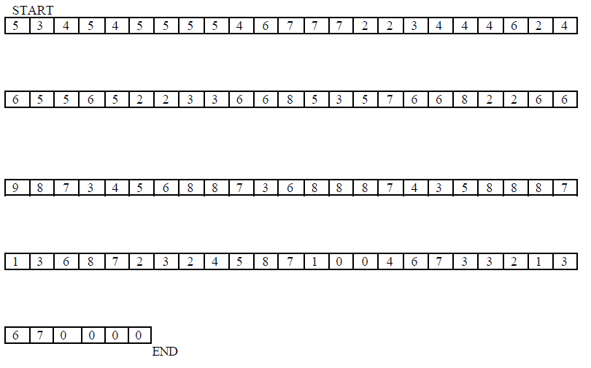

***Fig. 1***

Figure 2 prepares the format of the digital image. Band “A” and band “B” represent the same area on the earth”s surface, but are coded separately because they represent different portions of the electromagnetic spectrum (or colors of light).

**Task 2**

Insert the numbers from the tape into their appropriate geometric position thus: The first seven numbers of band “A” from the tape are positioned as pixels 1 - 7 of line No. 1 of the band “A” matrix in Figure 2. The next seven numbers from the tape are for pixels 1-7 of line No. 1 of band “B” in Figure 2. Continue in this manner until the two matrices of Figure 2 are filled.

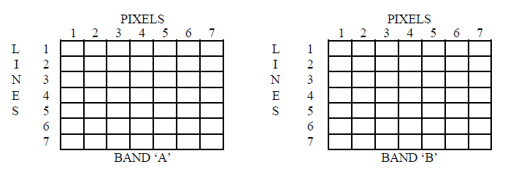

***Fig. 2***

The digital or numerical maps constructed in Figure 2 may now be converted into another format which will permit a visual appreciation of the image. A "grey map" is produced to synthesize a visual image from the numbers at hand.

The computer-produced grey maps usually present a problem, in that the number of intensity levels (64 to 256) greatly exceeds the number of available grey “shades” which the printing device can generate. Each pixel in the 7 x 7 image is coded at a particular intensity level from 0-9 (10 levels). It is appropriate in this simple example then, to use three shades of grey, in an attempt to represent the 10-level image.

**Task 3**

For each of the band A” and “B” digital images (Figure 2), transform the numerical values of each pixel into a "shade" of grey according to the following conversion:

Numerical Value 0 1 2 3 4 5 6 7 8 9

|  |  |  |  |
| --- | --- | --- | --- |
| Grey Level |  |  |  |

and sketch these “transformed” pixels into Figure 3. Note that the smallest intensities are represented as the “darkest”.



***Fig. 3***

Note that in the completed Figure 3, there are some similar and some dissimilar patterns appearing when bands “A” and “B” are compared. Although some environmental spatial patterns are beginning to appear, it is obvious that the grey maps represent much less information than is inherent in the digital maps.

Following are a number of techniques which are intended to give a better understanding of the

data.

An “intensity profile” gives a one-dimensional view of a single cross-section of the data. It is a

popular technique in photographic analysis as well, where a “density profile” is constructed.

**Task 4**

An intensity profile will be constructed for line number 6 of each of the band “A” and band “B” images. Use the graph outlines prepared in Figure No. 4. For band “A”, line No. 6, determine the intensity level for each pixel using the digital map, and plot a point to correspond to that pixel number and intensity level. When all seven points are plotted, join the points, progressing from pixel numbers 1 to 7. Repeat the same procedure for band “B”.

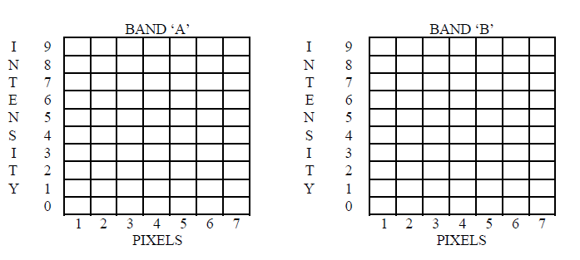

***Fig. 4***

The completed Figure 4 now represents the intensities of reflected light as found on the ground track which corresponds to line No. 6 of the image. These intensity profiles may be produced for any line drawn across the image (at any angle). The inherent limitations of this technique reduce its usefulness. A more informative data arrangement is described below.

A one-dimensional histogram offers a graphical representation of the data distribution for a single band. The plot (see Figure 5) shows the number of pixels which have a particular intensity level. This is an abstract, but important concept. Alternately, one may ask: “What area of the image corresponds to a particular intensity level?”

**Task 5**

For band “A”, count the number of pixels which have an intensity of zero. Use the digital image in Figure 2. Enter this number in the space provided below the left graph of Figure 5. Now count the number of times that the intensity level 1 occurs and similarly record it on Figure 5. Continue for all levels. Check that the sum of these values is 49 (= 7 x 7). Now plot these values on the graph and join the plotted points with straight lines, progressing from left to right. Similarly construct the histogram for band “B”.



***Fig. 5***

There are several observations to be made regarding the appearance of these two histograms. First, the fact that the two histograms are significantly different means that there is different information (and perhaps useful information) available from the two bands concerning the same pixel (or ground area). Second, note the various peaks of the histograms. Each peak separated from neighboring peaks by valleys is called a “mode” of the histogram. Often it is found that a mode corresponds to a particular feature on the ground. The presence of several of these modes (a multi-modal histogram) leads to the conclusion that several (different) environmental features have been imaged.

Next, consider the band “B” histogram. There are two major modes in this histogram, separated by the valley at intensity level 2. Since band “B” is a reflective infrared band, knowledge of the infrared reflection characteristics of land and water can help identify these two modes. Water strongly absorbs infrared, resulting in low reflectivity. The typically vegetation-covered land surfaces will have high reflection during the summer months. Thus, the assumption is made that the left peak or mode designates water while the large mode on the right is of the land surfaces. By counting the number of pixels in each mode, we already have an idea of the relative size of areas of land and water in the image, even though we haven’t seen the image as yet!