**PRACTICAL WORK #1**

**Measuring the distance and area of objects**

**Statement.** One of the most important things in cartography is the ability to accurately determine distances and areas on the ground using maps.

**Objective.** Measure the distances and areas of objects on maps.

**Required materials.** Maps of different scales, pencils, rulers, and calculators.

**Completing tasks.** A compass and ruler are used to measure rectilinear segments. The needles of the compass are set to scale and, without changing the solution, count the distance between the extreme points. Curvilinear segments are measured by successive deposition of the "step" of the compass, depending on the degree of tortuosity of the line. In the field, the method of wet thread is acceptable.

The shortest distance between points is usually measured on the map, while the real terrain (hills, mountains) makes adjustments. To take them into account when calculating distances, a correction factor is used, by which the calculated result is multiplied (Table 1).

L = l × k,

where L is the desired distance; l is the distance determined from the map; k is the correction coefficient reflecting the terrain and scale of the map.

Table 1

**Correction factor**

|  |  |  |  |
| --- | --- | --- | --- |
| Terrain | Corrective coefficient *k* | | |
| Scale | | |
| 1 : 50 000 | 1 : 100 000 | 1 : 200 000 |
| Mountainous | 1.15 | 1.2 | 1.25 |
| hilly | 1.05 | 1.1 | 1.15 |
| flat | 1.00 | 1.0 | 1.05 |

***Exercise 1*.** Using a ruler and a correction factor, find the distance in a straight line between two points on the map (Fig. 1) (1: 50 000):

1. Sofia – Razdrad, b) Varna – Burgas, d) Plovdiv -Sofia

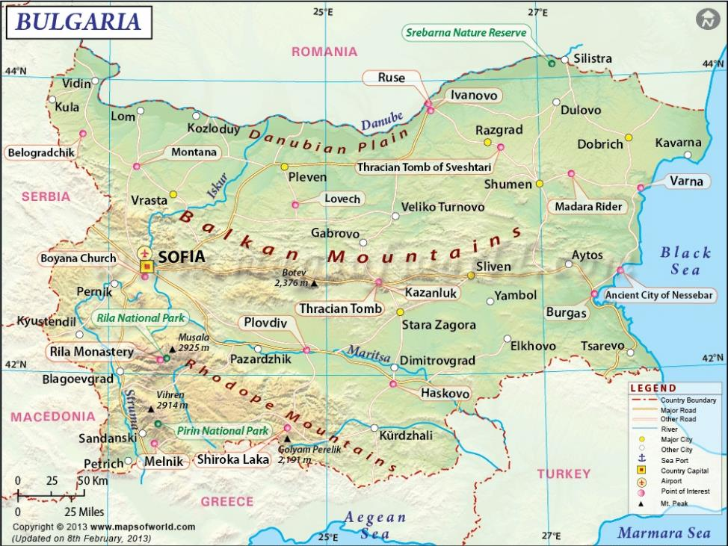

Fig. 1

***Exercise* 2.** Determine the area scale for maps of the following scales 1: 100, 1: 2000, 1 : 10 000, 1 : 25 000, 1 : 500 000, 1 : 1 000 000.

Task completion:

At a scale of 1 :10,000, the area scale will be (1)2 : (10,000)2 = 1 : 100 000 000. If we take into account that there are 10,000 m2 in 1 ha, then 100 ha in 1 km and 1 ha in 1 cm2. This means that in 1 cm2 of the map there is 1 ha on the ground.

***Exercise* 3.** Calculate the area of objects if they are equal to 20 cm2, 40 cm2, 50 cm2 on a 1:1000 scale map.

**PRACTICAL WORK #2**

**Cartographic projections**

**Statement.** In practical work with maps, students should be well versed in the geometric laws of construction and geometric properties of maps, be able to determine common projections by the type of grid, and calculate the size of object distortions.

**Objective.** To get acquainted with the features of cartographic projections, learn to recognize them by the type of grid of meridians and parallels. Explore the possibilities of their application.

**Required materials.** Maps and diagrams of cartographic projections, pencil, eraser, compass, ruler, tracing paper.

***Exercise 1.*** Answers on the questions:

* What kind projections called cylindrical, conical, azimuthal?
* How are they constructed?
* Where are the maximum and minimum distortions of shapes, angles, distances and areas?

***Exercise 2.*** Models of which projections are shown in Fig. 2, *a*, *b*, *c*?

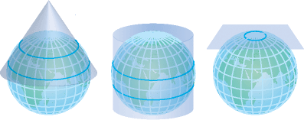

*a b c*

Fig. 2

***Exercise 3.*** Determine the type of projections from the drawing

Table 2

|  |  |  |
| --- | --- | --- |
| No. | Grid appearance for small scale maps | Type of projections |
| 1 |  |  |
| 2 |  |  |
| 3 |  |  |
| 4 |  |  |
| 5 |  |  |
| 6 |  |  |

***Exercise 3.*** Compare the distribution of distortions and their nature for different types of projections (Fig. 3, a, b). Record findings in a table.



*a*

**

*b*

Fig. 3

***Exercise 4.*** Carry out a classification of cartographic projections according to the type of meridians and parallels of the normal grid.

Table 3

**Projections and their features**

|  |  |
| --- | --- |
| Parallels are depicted: | Projections called |
| Lines of constant curvature |  |
| Lines of variable curvature |  |
| Straight lines |  |
| Arcs of concentric circles |  |
| Concentric circles |  |
| Eccentric circles |  |
| Curved lines |  |